**Task Instructions**

In this task you will see different shapes in the middle of the screen:

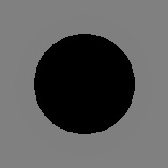

These shapes give you a hint for what you should do in the task.

If you see a circle, **prepare** to respond with the letter “c” on the keyboard.

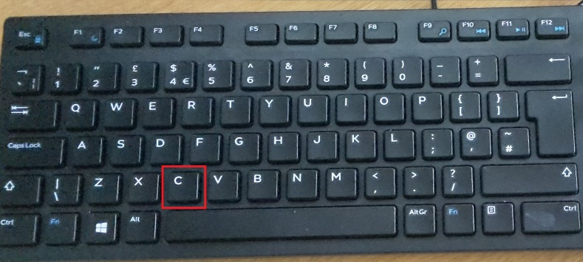

If you see a square, **prepare** to respond with the letter “m” on the keyboard.

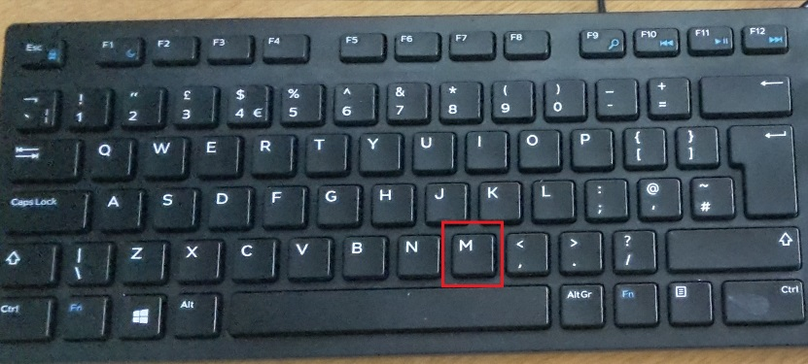

Wait until you see a triangle before you make your response.

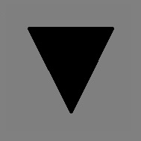

The triangle can appear either in the **middle** of the screen or on the **right** or on the **left** side of the screen.

**PRESS THE CHOSEN ARROW WHEN THE TRIANGLE APPEARS ON THE SCREEN.**

Throughout the task you will be instructed not to press anything. Sometimes when the triangle is on the **left** and sometimes when the triangle is on the **right.** You should always make a response when the triangle is in the middle.

If you press a button when you are not supposed to, you will see a message “incorrect” on the screen. If you press the wrong button, or not press anything at all when you should make a response you will also see the “incorrect” message.

Make sure you read the instructions again each time they appear on the screen.

The task is quite long, there are 6 blocks all together.

Important: respond as fast and accurate as you can and try to make a response every time there is a triangle on the screen.